Course Name:  Course Code: | Digital Logic Design Laboratory (DLDL)  316U06L202 | Semester: | II
Date of Performance: | 01/ 04 /2026 | Batch No: | A-1
Student Name: | Arav Arun | Roll No: | 16010125013
Faculty Sign & Date: |  | Grade/Marks: | / 2
Experiment No: 6
Title: Implementation of Boolean function using Decoder and 4 Bit Comparator
using IC 7485

Aim and Objective of the Experiment:
To study, design and implement logic functions using Decoder. Design and implement four bit binary comparator using IC 7485. Design and implement combinational logic circuits and their applications

COs to be achieved:
CO2: Represent, implement, and minimize logic functions using different techniques.
CO3: Implement combinational logic circuits and their applications using basic gates and MSI devices.
CO5: Understand basic principles required for advanced Digital Design

- Realize following combinational logic circuits using IC 74138 and logic gates and verify the working by providing different combinations of inputs.

- F1 (A, B, C) = Σ m ( 0 , 1 , 4 , 5 ) using IC 74138

Pin Diagram of IC 74138:

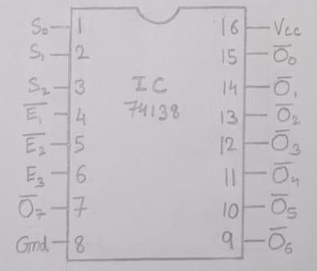

- Basic Idea (Logic Principle) : Decoder to implement a Boolean function

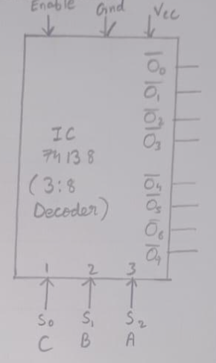

Logic Diagram: Given SOP equation using 8:1 MUX :

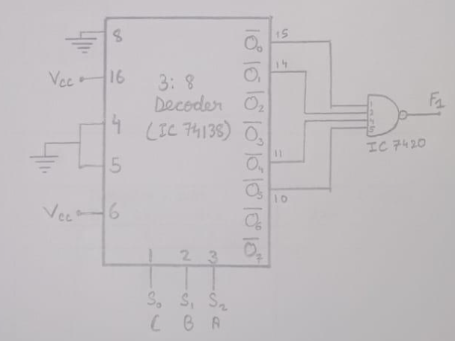

Truth Table :
Input |  |  | Output
A | B | C | Y
0 | 0 | 0 | 1
0 | 0 | 1 | 1
0 | 1 | 0 | 0
0 | 1 | 1 | 0
1 | 0 | 0 | 1
1 | 0 | 1 | 1
1 | 1 | 0 | 0
1 | 1 | 1 | 0

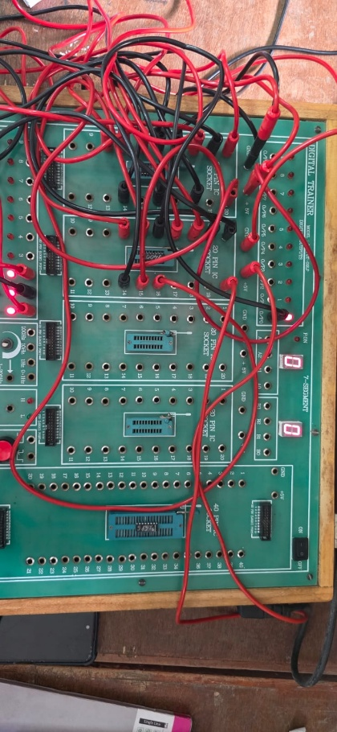
- Four bit binary comparator using IC 7485

Pin Diagram of IC 7485:

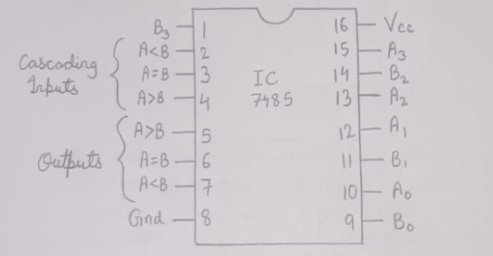

Functional Table of IC 7485:

Comparing Inputs  A,B | Cascading Inputs  A>B A=B A<B | Outputs  A>B A=B A<B
A>B | X X X | 1 0 0
A=B | 0 0 0  0 0 1  1 0 0  1 0 1  X 1 X | 1 0 1  0 0 1  1 0 0  0 0 0  0 1 0
A<B | X X X | 0 0 1

Truth Table: Try any 4 bit combination of A and B

Input A |  |  |  | Input B |  |  |  | Outputs
A3 | A2 | A1 | A0 | B3 | B2 | B1 | B0 | A>B | A=B | A<B
0 | 0 | 0 | 0 | 0 | 0 | 0 | 0 | 0 | 1 | 0
0 | 0 | 0 | 1 | 0 | 0 | 0 | 0 | 1 | 0 | 0
1 | 0 | 0 | 0 | 0 | 1 | 1 | 1 | 1 | 0 | 0
0 | 1 | 0 | 1 | 1 | 1 | 0 | 0 | 0 | 0 | 1
1 | 1 | 0 | 0 | 0 | 1 | 0 | 0 | 1 | 0 | 0
0 | 0 | 1 | 0 | 1 | 0 | 0 | 0 | 0 | 0 | 1
1 | 0 | 1 | 0 | 0 | 1 | 0 | 1 | 1 | 0 | 0
1 | 1 | 1 | 1 | 1 | 1 | 1 | 1 | 0 | 1 | 0
1 | 0 | 0 | 1 | 0 | 1 | 1 | 0 | 1 | 0 | 0
0 | 0 | 1 | 1 | 1 | 1 | 0 | 0 | 0 | 0 | 1
0 | 1 | 0 | 1 | 0 | 1 | 0 | 1 | 0 | 1 | 0
1 | 1 | 0 | 0 | 1 | 1 | 0 | 1 | 0 | 0 | 1
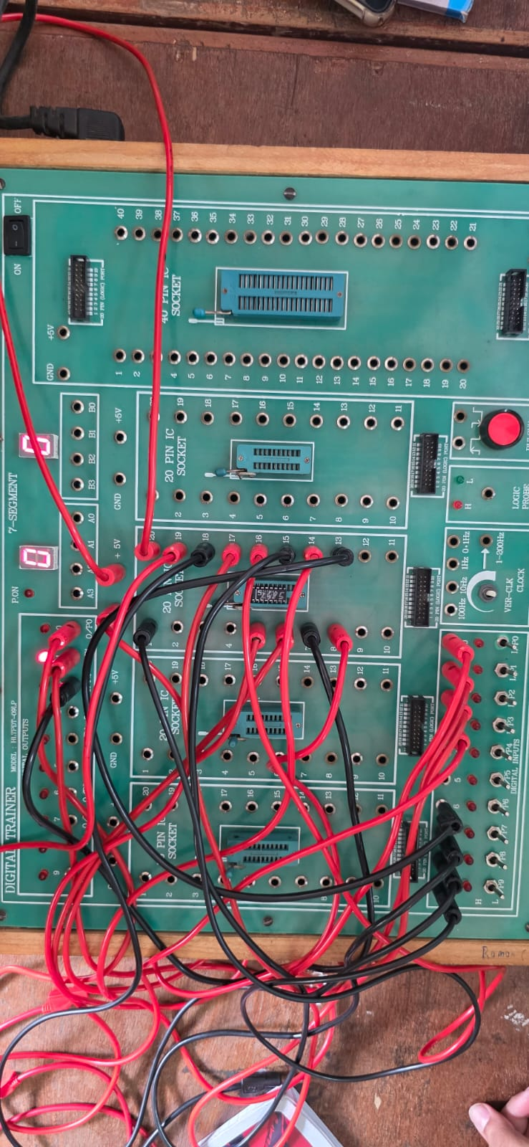

Conclusion: The given Boolean function was successfully implemented using IC 74138 and verified with different input combinations. The 4-bit comparator using IC 7485 was also tested and the outputs matched the expected results. Hence, the experiment was successfully performed and verified.

Signature of faculty in-charge with Date:

